**IoT Lite**

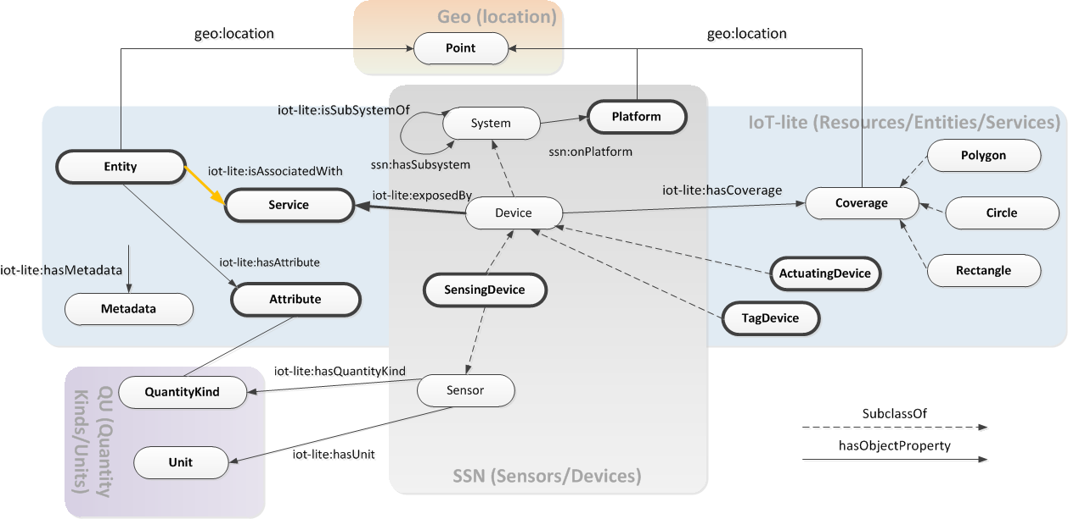

**Quality Ontology**



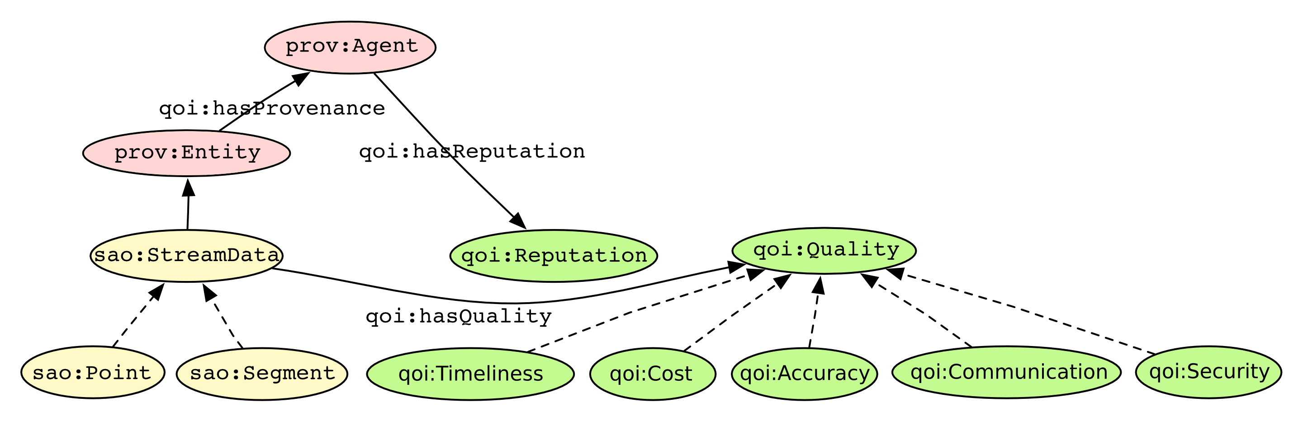

**SAO ontology**





**W3C SSN**

